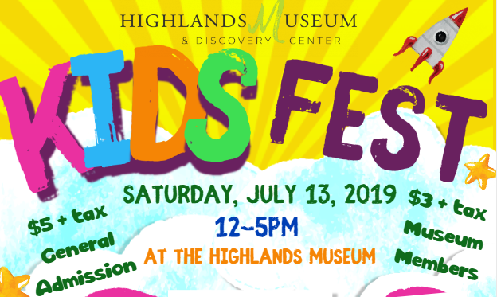

MAGIC MAKER LEVEL - $1,000

- Table at the event.
- Premium advertisement placement in program.
- Recognition in the museum’s main window located on Winchester Avenue.
- Recognition on stage banner.
- Top name recognition on all sponsor signs at the event.
- Recognition on the museum’s website and social media pages.
- Recognition in emcee announcements during the event.
- 10 tickets to Kids Fest.
- Free vendor booth for advertisement

ZOOKEEPER LEVEL - - $500

- Table at the event.
- Advertisement placement in program.
- Recognition in the museum’s main window located on Winchester Avenue.
- Recognition on all sponsor signs at the event.
- Recognition on the museum’s website and social media pages.
- Recognition in emcee announcements during the event.
- 5 tickets to Kids Fest.

Please fill out attached form and mail to the Highlands Museum & Discovery Center
1620 Winchester Avenue, Ashland, KY 41101
SPONSORSHIP OPPORTUNITIES
Kids Fest 2019
YES, COUNT ME IN!
July 13, 2019 – 12pm to 5pm

Sponsorship Level_____________________________________________________________

Company Name_____________________________________________________________

Contact Person____________________________________________________________

Address___________________________________________________________

City___________________State_________Zip Code_______________________

Telephone_________________________________________________________

Email Address___________________________________________________________

R.S.V.P. by June 21, 2019 to Amber Reeves at marketing.director@highlandsmuseum.com. Sponsorships are not confirmed until payment has been received. Checks can be made payable to the Highlands Museum & Discovery Center. Visa and MasterCard payments may be made by phoning the museum at (606)-329-8888. Forms can be emailed or mailed to the Museum at 1620 Winchester Avenue, Ashland, KY 41101.

I am unable to attend the event but am pleased to enclose my tax-deductible donation in the amount of $______________.

